

2012 Promotional Examination II
Pre-university 2

H1 CHEMISTRY 8872 / 01
Paper 1 Multiple Choice
18 Sep 2012
(TUESDAY)

50 minutes
Additional Materials: Data Booklet
Multiple Choice Answer Sheet

READ THESE INSTRUCTIONS FIRST

Write in soft pencil.
Do not use staples, paper clips, highlighters, glue or correction fluid.
Write your name, subject class and registration number on the Answer Sheet in the spaces provided unless this has been done for you.

There are forty questions on this paper. Answer all questions. For each question there are four possible answers A, B, C and D. Choose the one you consider correct and record your choice in soft pencil on the separate Answer Sheet.

Read the instructions on the Answer Sheet very carefully.

Each correct answer will score one mark. A mark will not be deducted for a wrong answer.
Any rough working should be done in this booklet.

Y
P
SECTION A

For each question there are four possible answers, A, B, C and D. Choose the one you consider to be correct.

1 | 10 cm³ of a hydrocarbon, C_{x}H_{y}, was exploded with an excess of oxygen. The mixture was then cooled to room temperature. There was a contraction of 35 cm³. When the product was treated with aqueous sodium hydroxide, there was a further contraction of 40 cm³.  Given that all volumes were measured at the same temperature and pressure, what is the formula of the hydrocarbon?
 | A | C₃H₆ |  |  | C |  | C₄H₈
 | B | C₃H₈ |  |  | D |  | C₄H₁₀
2 | When an excess of KI solution was added to 10.0 cm³ of a 0.200 moldm⁻³ solution of JO₄³⁻, the iodine liberated was titrated against a standard solution of 0.100 moldm⁻³ of sodium thiosulfate, Na₂S₂O₃, using starch as the indicator.  2S₂O₃²⁻ + I₂ → S₄O₆²⁻ + 2I⁻  If the volume of sodium thiosulfate required to discharge the blue-black coloration is 40.00 cm³, what is the final oxidation state of J?
 | A | -3 |  |  | C |  | +2
 | B | +1 |  |  | D |  | +3
3 | Which of the following is an isotope of oxygen?
 | A
 | B
 | C
 | D
4 | Two elements B and C have the following properties.  - B and C react with sodium to form ionic compounds Na₂B and Na₂C respectively.  - When reacted with fluorine, B forms only BF₂, while C forms CF₂ and CF₆.  Which of the following pairs of electronic configurations for B and C is correct?
 |  | B | C
 | A | 1s² 2s² 2p⁴ | 1s² 2s² 2p²
 | B | 1s² 2s² 2p² | 1s² 2s² 2p⁶ 3s² 3p²
 | C | 1s² 2s² 2p² | 1s² 2s² 2p⁶ 3s² 3p³
 | D | 1s² 2s² 2p⁴ | 1s² 2s² 2p⁶ 3s² 3p⁴
5 | Ice is the crystalline form of water. The diagram below shows part of the structure of ice.  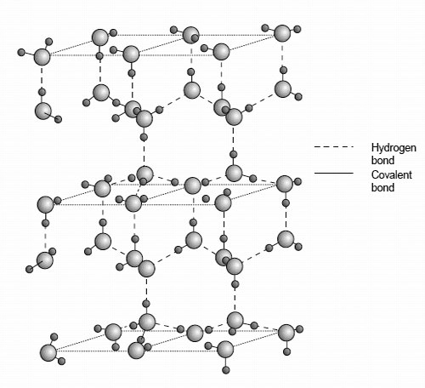  Which of the following statements is not true about ice?
 | A | Ice has a lower density than water at 0 °C due to its open structure.
 | B | The bond angle about oxygen in ice is 109.5°.
 | C | Ice has a giant covalent structure.
 | D | Ice does not conduct electricity.
6 | Which of the following sets contains one ionic, one simple molecular, and one macromolecular substance?
 | A | Iodine, hydrogen bromide and diamond
 | B | Silicon, aluminium oxide and silicon oxide
 | C | Water, potassium carbonate and diamond
 | D | Silicon, aluminium chloride and carbon dioxide
7 | The explosive nitroglycerin (C₃H₅N₃O₉) decomposes rapidly upon ignition or sudden impact according to the following equation:  4C₃H₅N₃O₉(l) → 12CO₂(g) + 10H₂O(g) + 6N₂(g) + O₂(g), ∆Hº_{r} = −5678 kJ mol⁻¹  Given the following data, what is the standard enthalpy change of formation of nitroglycerin in kJ mol⁻¹?  Standard enthalpy change of formation of CO₂(g) = −394 kJ mol⁻¹  Standard enthalpy change of formation of H₂O(g) = −242 kJ mol⁻¹
 | A | −368 |  |  | C |  | −1470
 | B | +368 |  |  | D |  | +1470
8 | Given: KOH(aq) + HBr(aq) → KBr(aq) + H₂O(l) ΔH_{r} = −57 kJ mol⁻¹  Which of the following will have the same value for the enthalpy change of reaction, ΔH_{r}, as the above reaction?
 | A | NH₃(aq) + HBr(aq) → NH₄Br(aq) + H₂O(l)
 | B | NaOH(aq) + ½H₂SO₄(aq) → ½Na₂SO₄(aq) + H₂O(l)
 | C | ½Ba(OH)₂(aq) + CH₃CO₂H(aq) → ½Ba(CH₃CO₂)₂(aq) + H₂O(l)
 | D | Ba(OH)₂(aq) + 2HNO₃(aq) → Ba(NO₃)₂(aq) + 2H₂O(l)
9 | Iodide ions react with peroxodisulfate ions to form iodine and sulfate ions:  2I–(aq) + S₂O₈^{2–}(aq) I₂(aq) + 2SO₄^{2–}(aq)  In an experiment, 5.0 mol dm^{–3} Na₂S₂O₈ was reacted with 0.025 mol dm^{–3} KI. The half-life for this reaction was found to be 6.9 s. Given that the above reaction is first order with respect to I– and S₂O₈^{2–} ions respectively, determine the rate constant of this reaction in mol^{–1} dm³ s^{–1}.
 | A | 0.01 |  |  |  | C |  | 0.1
 | B | 0.02 |  |  |  | D |  | 0.2
10 | Consider the following reaction: E + 3F → EF₃  The mechanism involves the following steps:  2F F₂ fast  E + F₂ → EF₂ slow  EF₂ + F → EF₃ fast  Based on the information given, what is the rate equation for this reaction?
 | A | Rate = k[F]²
 | B | Rate = k[E][F]²
 | C | Rate = k[E][F]³
 | D | Rate = k[E][F₂]
11 | Potassium-argon dating is used to determine the age of igneous rocks. Potassium in these rocks gradually breaks down into argon and the gas is trapped in the rock. This radioactive decay is first order reaction with a half-life of 1.3 x 10⁹ years.  A sample of igneous rock, containing some potassium, is examined. If the amount of argon gas measured is 7 times as much as the amount of potassium, what is the age (in years) of the rock?
 | A | 1.3 x 10⁹ |  |  |  | C |  | 3.9 x 10⁹
 | B | 2.6 x 10⁹ |  |  |  | D |  | 9.1 x 10⁹
12 | Given that the energy profile diagram for a chemical reaction is as follows,  Energy/kJ mol⁻¹  Reaction progress  Which of the following can be deduced from the energy profile diagram?
 | A | The reaction involves the formation of two intermediates.
 | B | The rate constant of the second step is larger than the first.
 | C | When the reaction is carried out, temperature of the surroundings will increase.
 | D | The difference between the values of the activation energies of the first and second step is the enthalpy of reaction.
13 | Which statement concerning the following equilibrium reaction is true?  Cr₂O₇²⁻(aq) + H₂O(l)2CrO₄²⁻(aq) + 2H⁺(aq)
 | A | It involves a redox reaction.
 | B | The equilibrium constant, K_{c}, has the units of mol² dm⁻⁶.
 | C | A decrease in pH will result in an increase in [Cr₂O₇²⁻(aq)].
 | D | Addition of a catalyst will result in an increase in [Cr₂O₇²⁻(aq)].
14 | Which of the following pairs of solutions would form an acidic buffer when mixed together?
 | A | HCN and NaCN |  |  |  | C |  | NaOH and NaCl
 | B | HNO₃ and NaNO₃ |  |  |  | D |  | HCl and NaOH
15 | One mole of magnesium, aluminium and sulfur are each completely burnt in an excess of oxygen gas. Which graph shows the volume of oxygen used in each case?
 | A | Mg Al S  volume of oxygen used  0 |  |  |  | C |  | volume of oxygen used  0  Mg Al S
 | B | volume of oxygen used  0  Mg Al S |  |  |  | D |  | volume of oxygen used  0  Mg Al S
16 | Which of the following sketches shows the correct trend in the stated property, for the elements in the third period of the Periodic Table?  A B  atomic radius  Na Mg Al Si P S Cl  Na Mg Al Si P S Cl  electrical conductivity  melting point  Na Mg Al Si P S Cl  Na Mg Al Si P S Cl  electronegativity  C D
17 | The following reaction scheme shows the synthesis of compound C from methylbenzene.  Compound C compound C  I  II  Which of the following shows the correct reaction types for steps I and II?
 |  | I |  | II
 | A | addition |  | addition
 | B | addition |  | condensation
 | C | substitution |  | substitution
 | D | substitution |  | elimination

18 | Compound P can be used to make the hard outer covering of golf balls.  Compound P  Which of the following is true about P?

 | A | It can react with Fehling’s solution.
 | B | It undergoes oxidation with potassium dichromate (VI).
 | C | One mole of P can react exactly with 2 moles of hydrogen gas.
 | D | It can react with ethanol in the presence of a little concentrated H₂SO₄ on heating.
19 | Four drops of 1-chorobutane, 1-bromobutane and 1-iodobutane were separately added to three test-tubes containing 1.0 cm³ of aqueous silver nitrate at 60 °C. The following reaction occurred.  H₂O(l) + R–X(l) + Ag⁺(aq) → R–OH(aq) + AgX(s) + H⁺(aq)  [R: C₄H₉–; X: halogen]  Which of the following best explains why the rate of formation of cloudiness (precipitate) in the tubes was in the order RCl < RBr < RI?

 | A | The R–X bond polarity decreases from RCl to RI.
 | B | The bond energy of R–X decreases from RCl to RI.
 | C | The solubility of AgX(s) decreases from RCl to AgI.
 | D | The ionisation energy of the halogen decreases from Cl to I.
20 | 1 mole of an organic compound K reacts with 2 moles of NaOH(aq) when heated.  1 mole of K also reacts with PCl₅ to produce 1 mole of HCl(g).  Which compound could K be?

 | A |  | C
 | B |  | D
21 | Aspirin is a common analgesic used in the treatment of headaches and muscle aches. Its structure is shown below:  Which of the following is true about aspirin?

 | A | It is soluble in water.
 | B | Its aqueous solution is acidic.
 | C | It gives a yellow precipitate when warmed with aqueous alkaline iodine.
 | D | It gives orange precipitate when warmed with 2,4-dinitrophenylhydrazine.

22 | Acarol is sold as an insecticide for use on fruit and vegetables.  The final stage in its manufacture is an esterification reaction.  Which alcohol is used in the final stage to form Acarol?

 | A | di(4-bromophenyl)methanol | C | propan-1-ol
 | B | methanol | D | propan-2-ol
23 | Which of the following compounds form two different organic products when it is heated with acidified potassium manganate(VII) solution?

 | A | CH₂=CHCH₂CH=CH₂
 | B
 | C
 | D

24 | The reaction scheme below shows the synthesis of compound S.  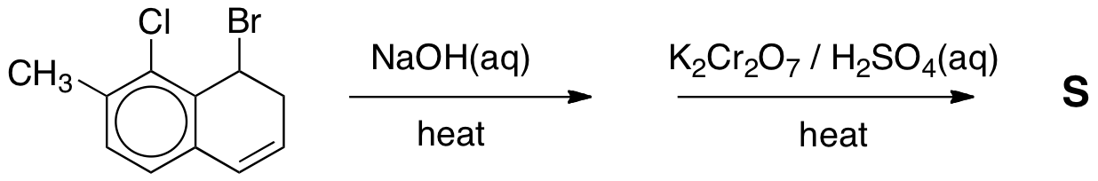  R  KMnO₄ in H₂SO₄  Which of the following shows the structural formula of S?

 | A | 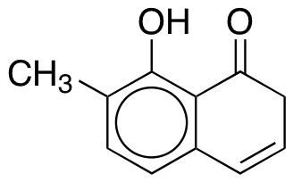 | C | 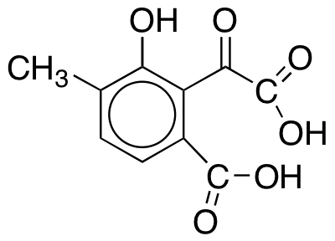
 | B | 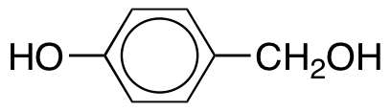 | D | 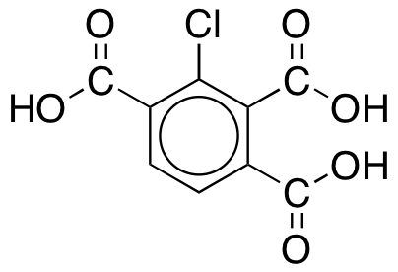
25 | How many alcohol structural isomers does molecular formula, C₄H₁₀O have?

 | A | 1
 | B | 2
 | C | 3
 | D | 4

SECTION B

For each of the questions in this section, one or more of the three numbered statements 1 to 3 may be correct. Decide whether each of the statements is or is not correct.

The responses A to D should be selected on the basis of

A | B | C | D
1,2 and 3  are correct | 1 and 2  only are correct | 2 and 3  only are correct | 1 only  is correct

No other combination of statements is to be used as a correct response.

26 | Which of the following correctly show(s) an increase in the radii?
 | 1 | Ca²⁺ < K⁺ < Ar
 | 2 | Cl– < S^{2–} < P^{3–}
 | 3 | Na < Mg < Al

27 | Which of the following statements is/are true about metallic bonding?
 | 1 | The larger the size of the metal cation, the stronger is the metallic bonding.
 | 2 | The greater the charge of the metal cation, the stronger is the metallic bonding.
 | 3 | The greater the number of valence electrons the metal has, the stronger is the metallic bonding.

28 | Which of the following reactions has/have an endothermic enthalpy change?
 | 1 | Cl–(g) → Cl(g) + e–
 | 2 | NaCl(s) → Na⁺(g) + Cl–(g)
 | 3 | CH₄(g) + Cl₂(g) → CH₃Cl(g) + HCl(g)

 | 29 |  | Which of the following compounds will react with sodium metal to release hydrogen?
 |  |  | 1 | CH₃CH₂OH
 |  |  | 2 | CH₃CH(OH)CH₃
 |  |  | 3 | C₂H₅COOH
 | 30 |  | (CH₃)₂C=CH₂ in Solution Y  Solution Z  Given that a precipitate is formed in solution Z, which of the following are the identities of the solution Y and Z?
 |  |  |  | Solution Y | Solution Z
 |  | 1 |  | Hot acidic KMnO₄ | Ca(OH)₂(aq)
 |  | 2 |  | Hot alkaline KMnO₄ | 2,4-dinitrophenylhydrazine
 |  | 3 |  | Hot acidic K₂Cr₂O₇ | Aqueous alkaline iodine

BLANK PAGE

BLANK PAGE

ANSWER SHEET (H1)

Question Number | Key |  | Question Number | Key
1 | D |  | 16 | C
2 | D |  | 17 | C
3 | B |  | 18 | C
4 | D |  | 19 | B
5 | C |  | 20 | B
6 | C |  | 21 | B
7 | A |  | 22 | D
8 | B |  | 23 | D
9 | B |  | 24 | D
10 | B |  | 25 | D
11 | C |  | 26 | B
12 | B |  | 27 | C
13 | C |  | 28 | B
14 | A |  | 29 | A
15 | D |  | 30 | B

